Student.java

package com.example.studentmanagement;  
  
 class Student {  
 private int regNo;  
 private String name;  
 private String course;  
 private int age;  
 Student()  
 {  
  
 }  
 Student(int regNo,String name, int age,String course)  
 {  
 this.regNo=regNo;  
 this.name=name;  
 this.age=age;  
 this.course=course;  
 }  
  
 public int getRegNo() {  
 return regNo;  
 }  
  
 public void setRegNo(int regNo) {  
 this.regNo = regNo;  
 }  
  
 public String getName() {  
 return name;  
 }  
  
 public void setName(String name) {  
 this.name = name;  
 }  
  
 public String getCourse() {  
 return course;  
 }  
  
 public void setCourse(String course) {  
 this.course = course;  
 }  
  
 public int getAge() {  
 return age;  
 }  
  
 public void setAge(int age) {  
 this.age = age;  
 }  
 }

**Student Controller.java**

package com.example.studentmanagement;  
  
import org.springframework.beans.factory.annotation.Autowired;  
import org.springframework.http.HttpStatus;  
import org.springframework.http.ResponseEntity;  
import org.springframework.web.bind.annotation.*;  
  
import java.util.HashMap;  
import java.util.Map;  
  
@RestController //this class is containing api  
public class StudentController {  
// Map<Integer,Student> db= new HashMap<>();  
 @Autowired  
 StudentService ss;  
 @GetMapping("/get")  
public Student getStudent(@RequestParam("regNo") int regNo)  
{  
 return ss.getStudent(regNo);  
}  
  
@PostMapping("/add")  
public String addStudent(@RequestBody Student student)  
{  
 ss.addStudent(student);  
 return "Student addes Successfully";  
}  
  
@GetMapping("/getUsingPath/{id}")  
public ResponseEntity addUsingPathById(@PathVariable(" ") int regNo)  
{  
 Student s=ss.addUsingPathById(regNo);  
 if(s==null)  
 {  
 return new ResponseEntity<>("Student Not Found", HttpStatus.*NOT_FOUND*);  
 }  
 else{  
 return new ResponseEntity(s,HttpStatus.*FOUND*);  
 }  
}  
  
@PutMapping("/update/{id}")  
public Student updateStudent(@PathVariable("id") int regNo,@RequestParam("age") int newAge)  
{  
  
 return ss.updateStudent(regNo,newAge);  
}  
  
@PutMapping("/updateStudentCourse/{course}/{regNo}")  
public Student updateStudentCourse(@PathVariable("regNo") int regNo,@PathVariable("course") String course)  
{  
  
 return ss.updateStudentCourse(regNo,course);  
}  
}

**Student Services.java**

package com.example.studentmanagement;  
  
import org.springframework.beans.factory.annotation.Autowired;  
import org.springframework.stereotype.Service;  
  
@Service  
public class StudentService {  
  
  
  
 @Autowired  
 StudentRepository sr;  
 public Student getStudent(int regNo)  
 {  
 Student s=sr.getStudent(regNo);  
 return s;  
 }  
  
 public String addStudent(Student student)  
 {  
 sr.addStudent(student);  
 return "Student Added";  
 }  
  
 public Student addUsingPathById(int regNo) {  
 return sr.addUsingPathById(regNo);  
 }  
  
 public Student updateStudent(int regNo, int newAge) {  
 return sr.updateStudent(regNo,newAge);  
 }  
  
 public Student updateStudentCourse(int regNo, String course) {  
 return sr.updateStudentCourse(regNo,course);  
 }  
}

**StudentRepository.java**

package com.example.studentmanagement;  
  
import org.springframework.stereotype.Repository;  
  
import java.util.HashMap;  
import java.util.Map;  
  
@Repository  
public class StudentRepository {  
 Map<Integer,Student> db= new HashMap<>();  
  
 public Student getStudent(int regNo)  
 {  
 return db.get(regNo);  
 }  
  
 public void addStudent(Student student)  
 {  
 db.put(student.getRegNo(),student);  
return;  
 }  
  
 public Student addUsingPathById(int regNo) {  
 return db.get(regNo);  
 }  
  
 public Student updateStudent(int regNo, int newAge) {  
 db.get(regNo).setAge(newAge);  
 return db.get(regNo);  
 }  
  
 public Student updateStudentCourse(int regNo, String course) {  
 db.get(regNo).setCourse(course);  
 return db.get(regNo);  
 }  
}

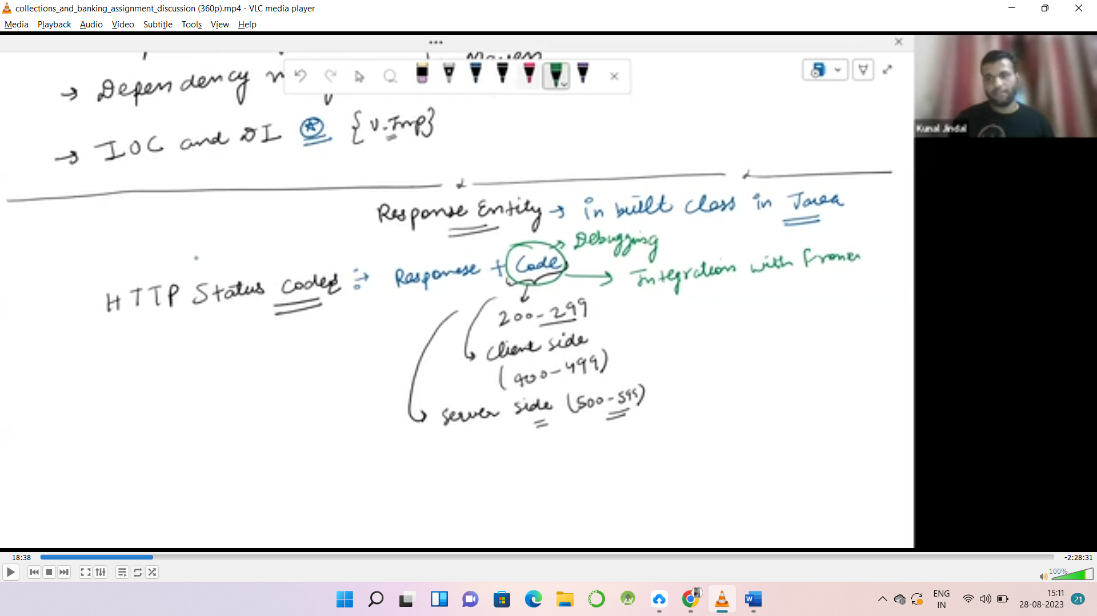

**HTTP Status Code**

Clent side= 400- 499

Server Side = 500- 599

MDN Web Docs Website: understanding web development

Response Entity= it’s a java class which help us to send response + status

Suppose getStudent() is a function

And I want toreturn a student by comparing id and if student is not in the map i.e it is null I should send a string “Not Found” so what should be return type of this we cant decide

So we use ResponseEntity

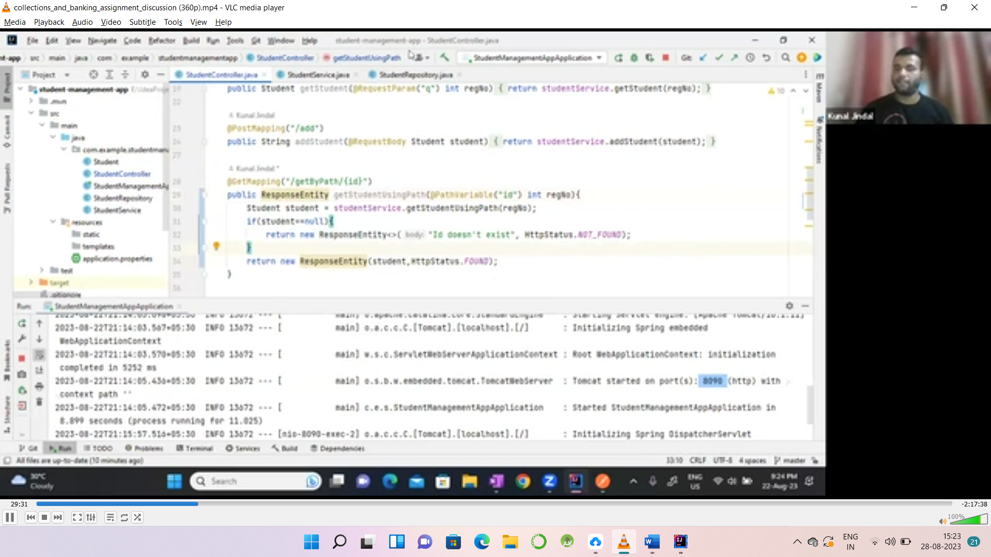

If I want to use angular bracket ResponseEntity<String> for if I want to use only only data type

@GetMapping("/getUsingPath/{id}")  
public ResponseEntity addUsingPathById(@PathVariable(" ") int regNo)  
{  
 Student s=ss.addUsingPathById(regNo);  
 if(s==null)  
 {  
 return new ResponseEntity<>("Student Not Found", HttpStatus.*NOT_FOUND*);  
 }  
 else{  
 return new ResponseEntity(s,HttpStatus.*FOUND*);  
 }  
}

Dependency management By Maven

* External libraries
* .m2: maven downloads the dependency
* MavenRepo(Public Repo): when first we download a spring it will first go to this repo anddownload dependeny then it will store in .m2 folder
* .m2: local repo for dependeny
* Private Repo: Nexes

Public repo



.m2

Local project

**IOC and DI**

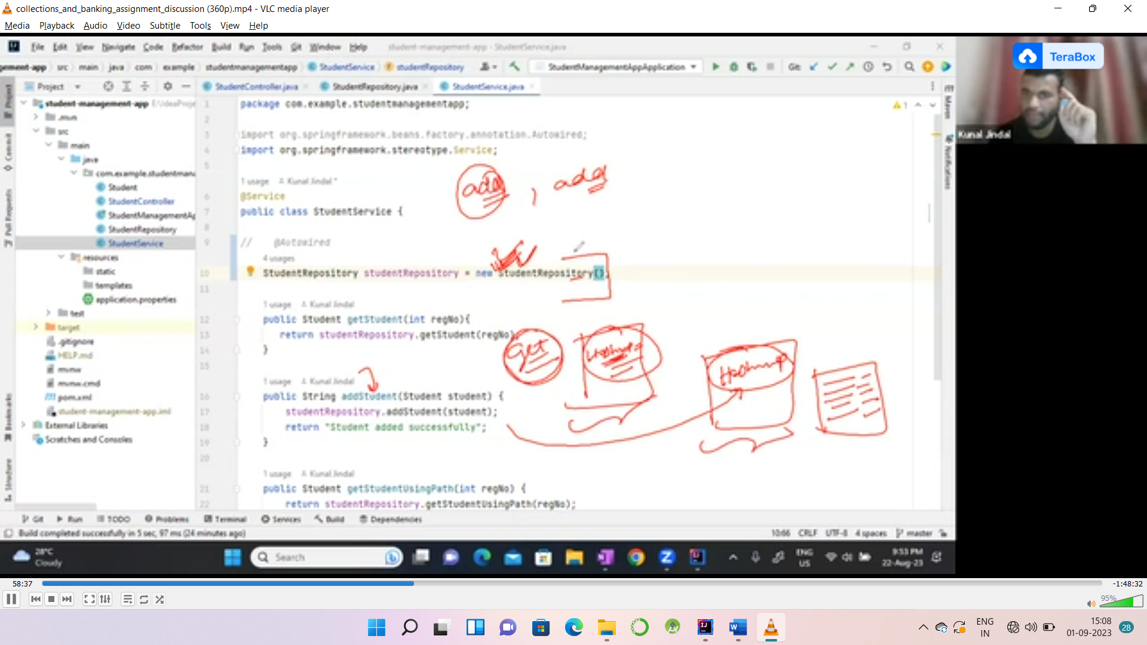

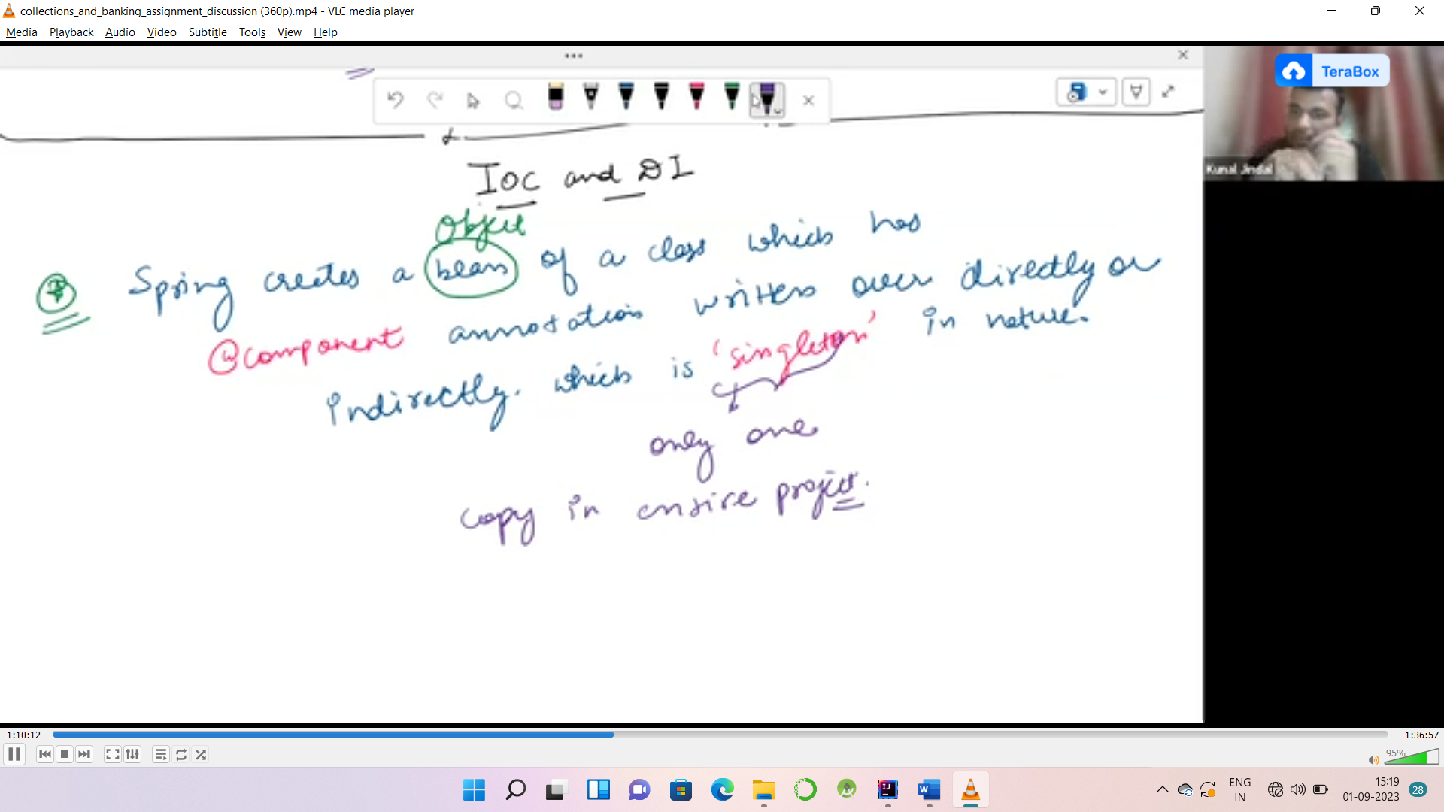



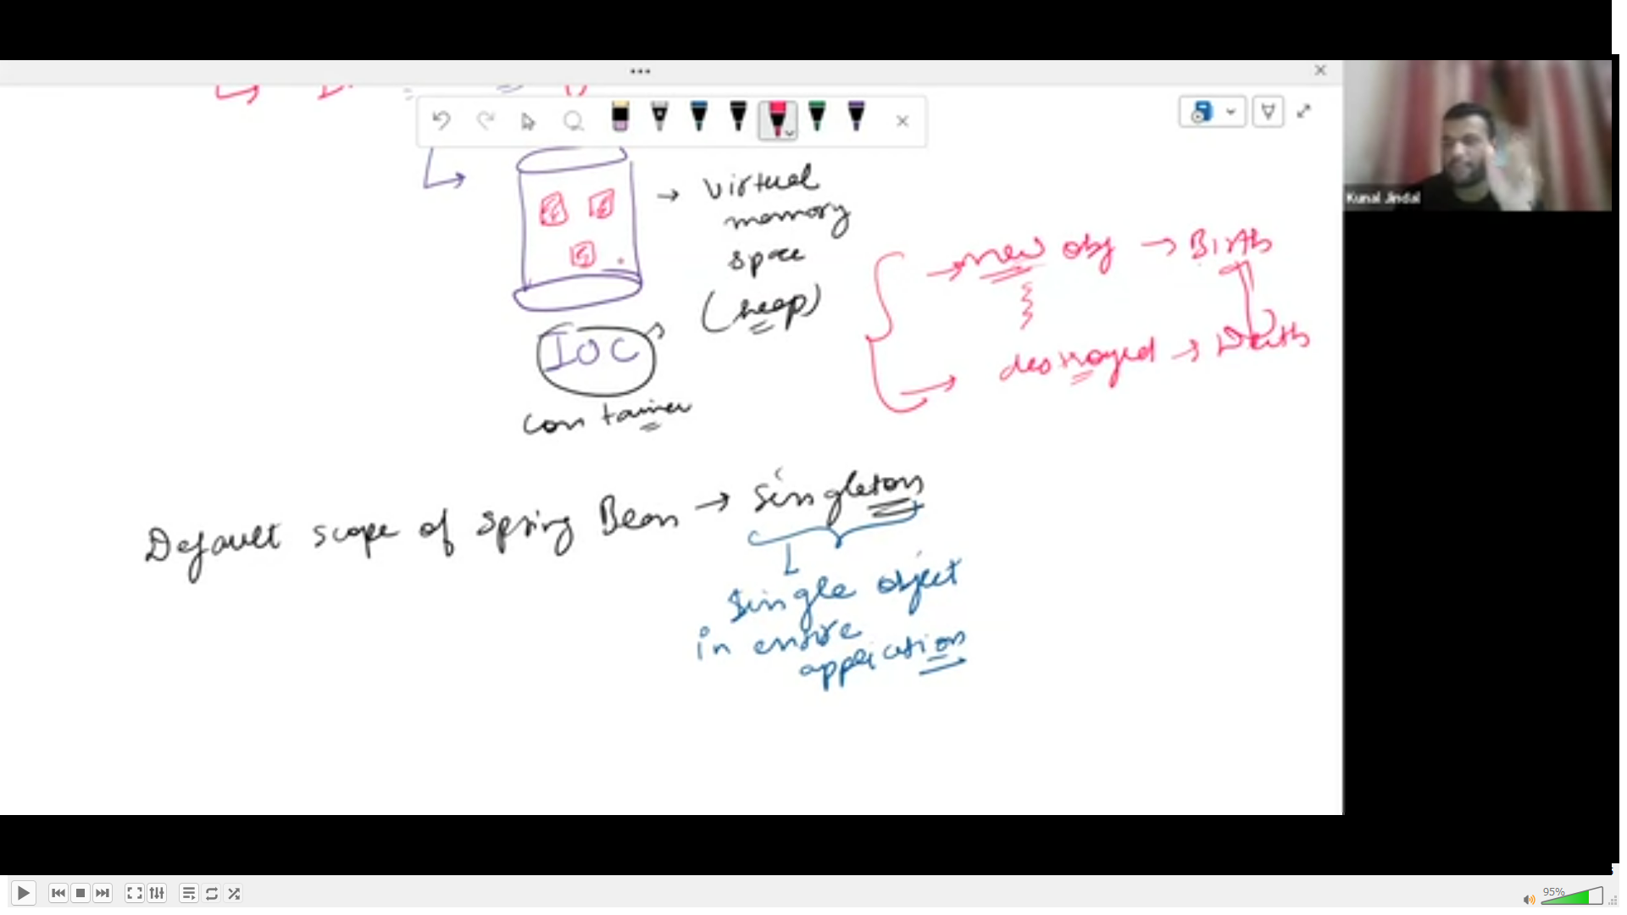

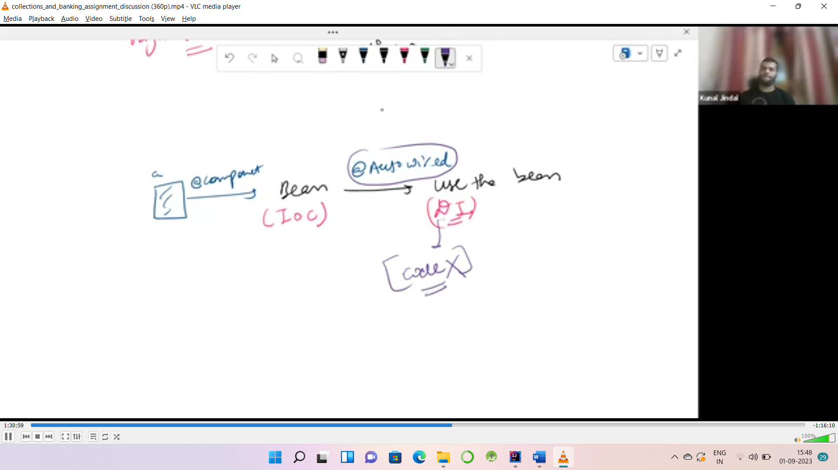

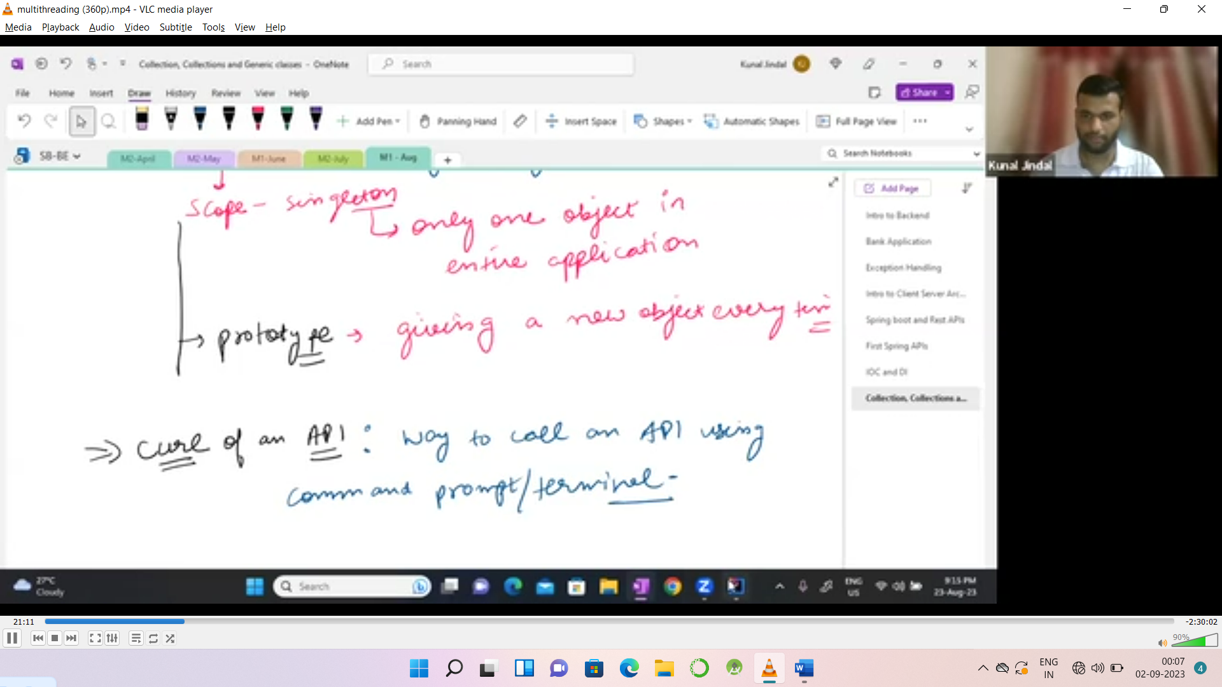@Repository  
@Scope("prototype") //Giving new obj everytime its a one kind of scope  
public class StudentRepository {  
 Map<Integer,Student> db= new HashMap<>();  
  
 public Student getStudent(int regNo)  
 {  
 return db.get(regNo);  
 }  
  
 public void addStudent(Student student)  
 {  
 db.put(student.getRegNo(),student);  
return;  
 }



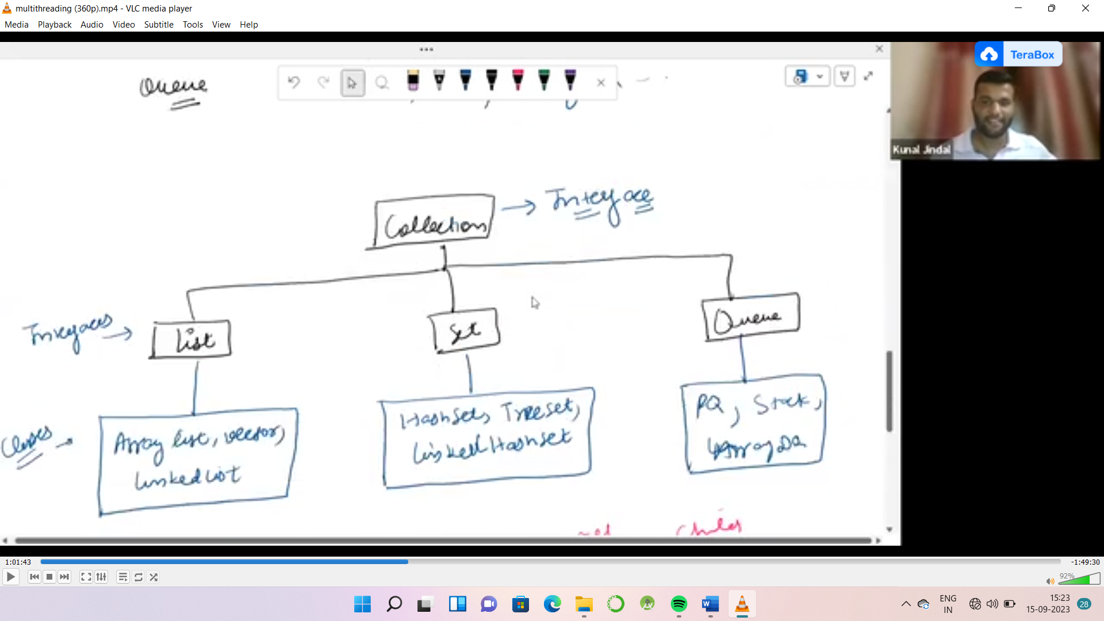

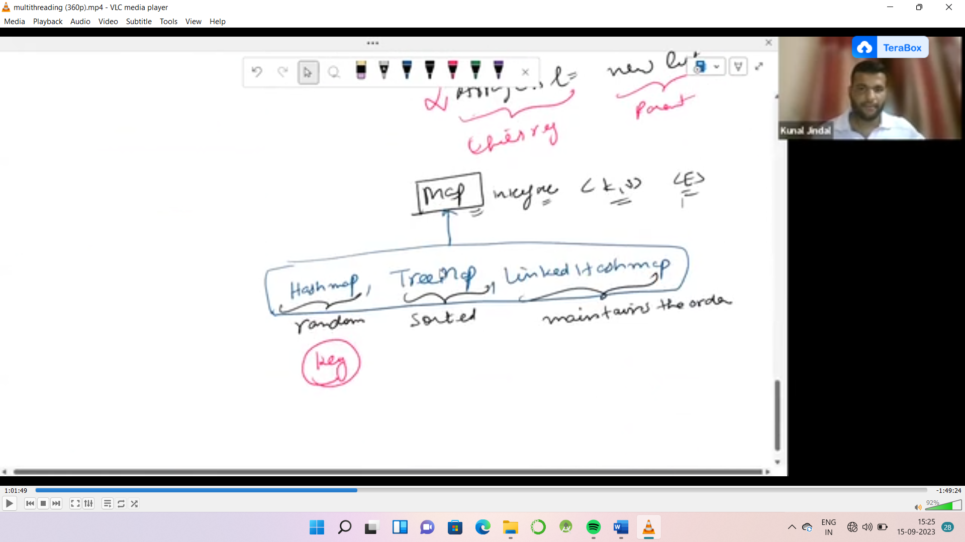

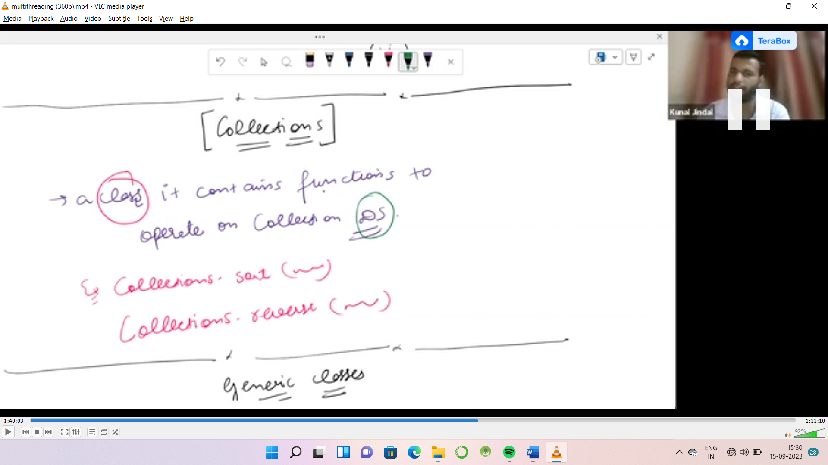

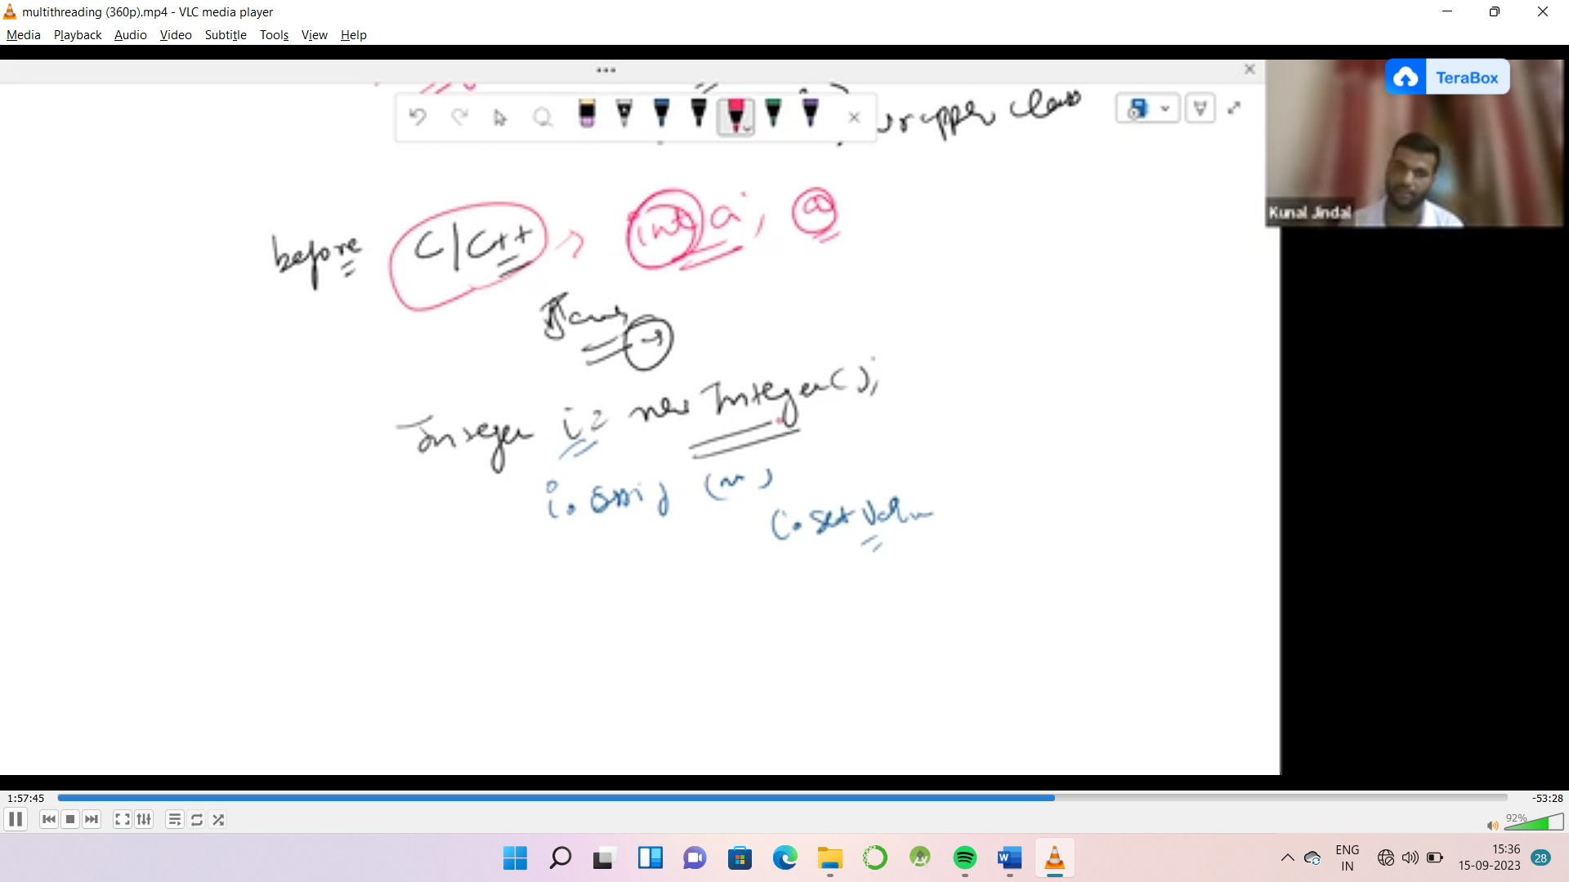

**Generic Class:**

**Public T void fun(T a) {}**

**Public interface Set<E> {}**

**Public interface Map<k,v> {}**

<Class> it only accept a class in angular brackets

List<int> l=new ArrayList<>(); // it is not acceptable int is a data type

Valid way: List<Integer> l=new ArrayList<>();

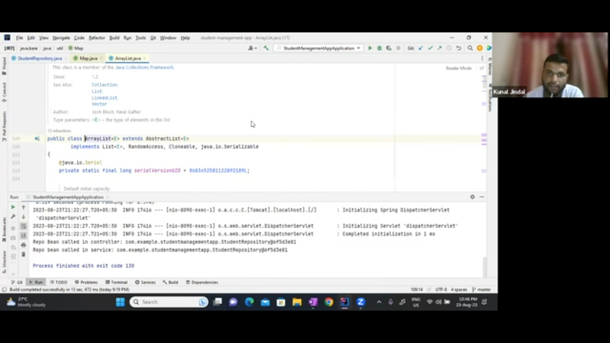

**Multithreading**

Multitasking: ruunung multiple application/process at same time.

Multithreading: MSWord(Typing+spelling checking+formatting)

Running a multiple thread of the same time.

Thread: sub process , part of process light weuht process

In one application how many task are ruuning at the same time : multithreading

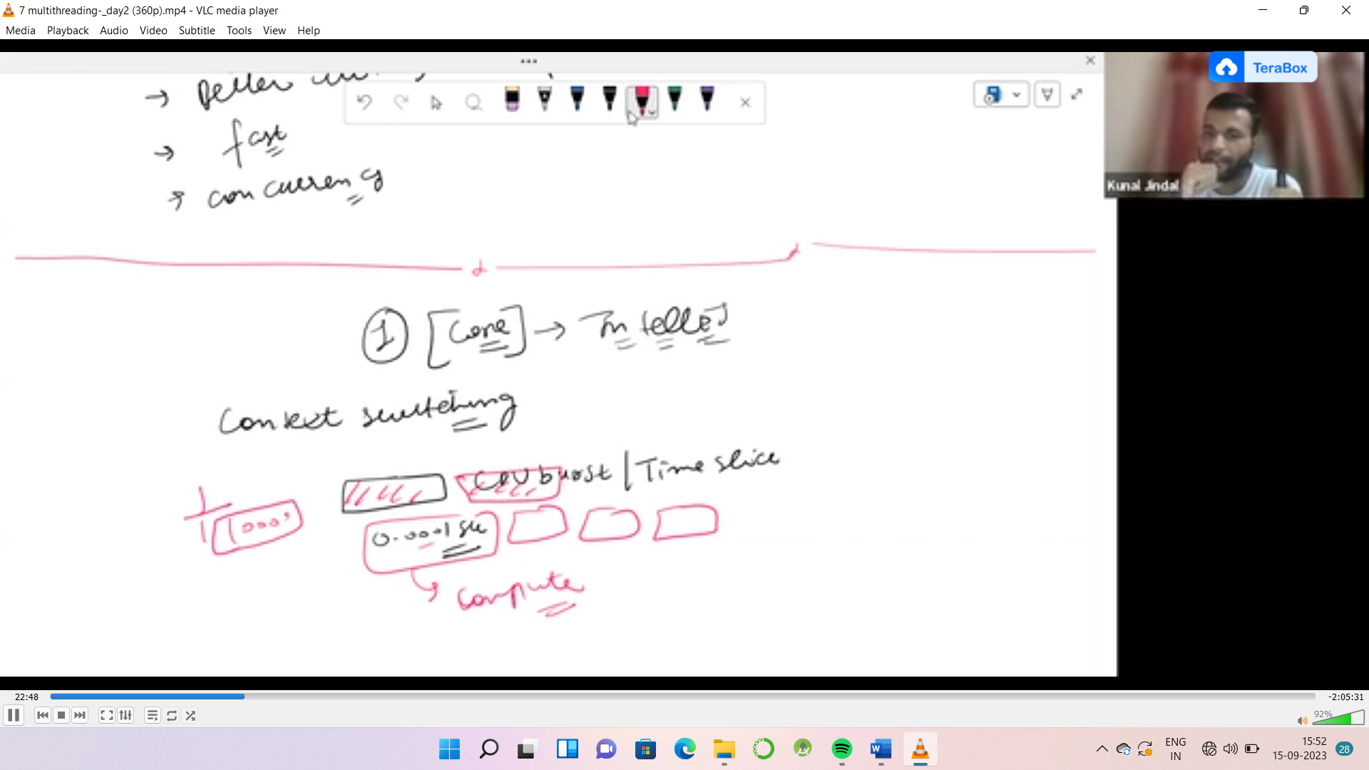

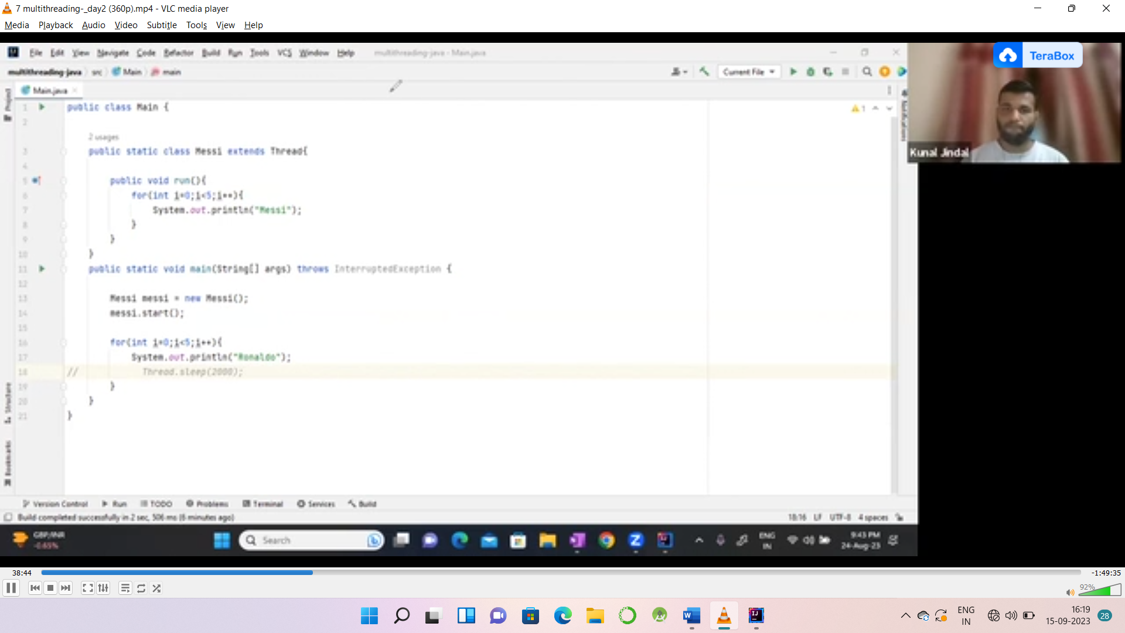

import java.lang.Thread;  
public class MultiThreadCode extends Thread{  
 public void run()  
 {  
 for(int i=0;i<5;i++) {  
 System.*out*.println("hi");  
 }  
 }  
 public static void main(String[] args) throws InterruptedException {  
 MultiThreadCode m=new MultiThreadCode();  
 m.start();  
 for(int i=0;i<5;i++) {  
 System.*out*.println(i);  
  
 }  
 }  
}

Output

0

1

2

3

4

hi

hi

hi

hi

hi

MultiThreadCode m=new MultiThreadCode();  
m.start();  
  
  
 for(int i=0;i<5;i++) {  
 System.*out*.println(i);  
 Thread.*sleep*(2000);  
 }

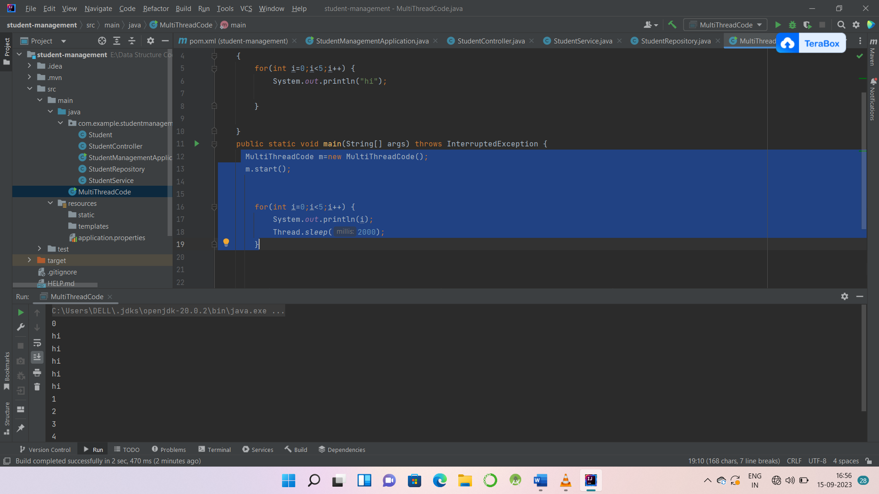

import java.lang.Thread;  
public class MultiThreadCode extends Thread{  
 public void run()  
 {  
 for(int i=0;i<5;i++) {  
 System.*out*.println("Messi");  
  
 }  
  
 }  
 public static void main(String[] args) throws InterruptedException {  
 MultiThreadCode m=new MultiThreadCode();  
 m.start();  
// Thread.sleep(2000);  
  
 for(int i=0;i<5;i++) {  
 System.*out*.println("Ronaldo");  
// Thread.sleep(2000);  
 }  
  
 }  
}

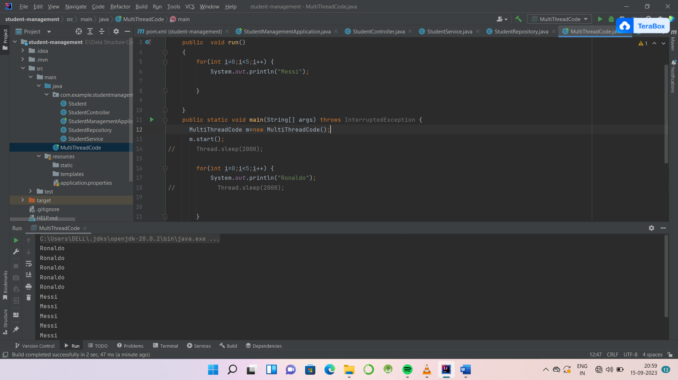

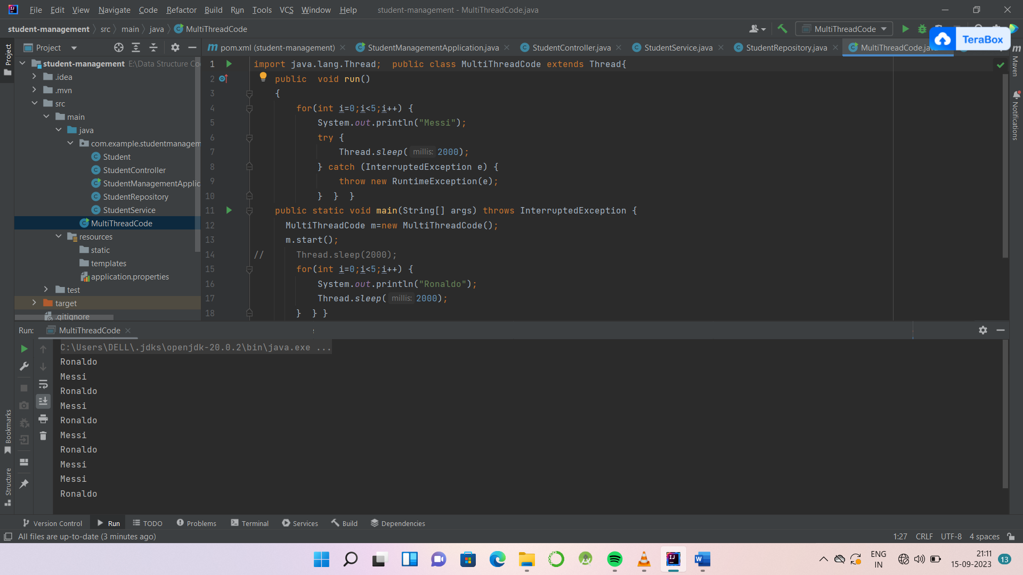

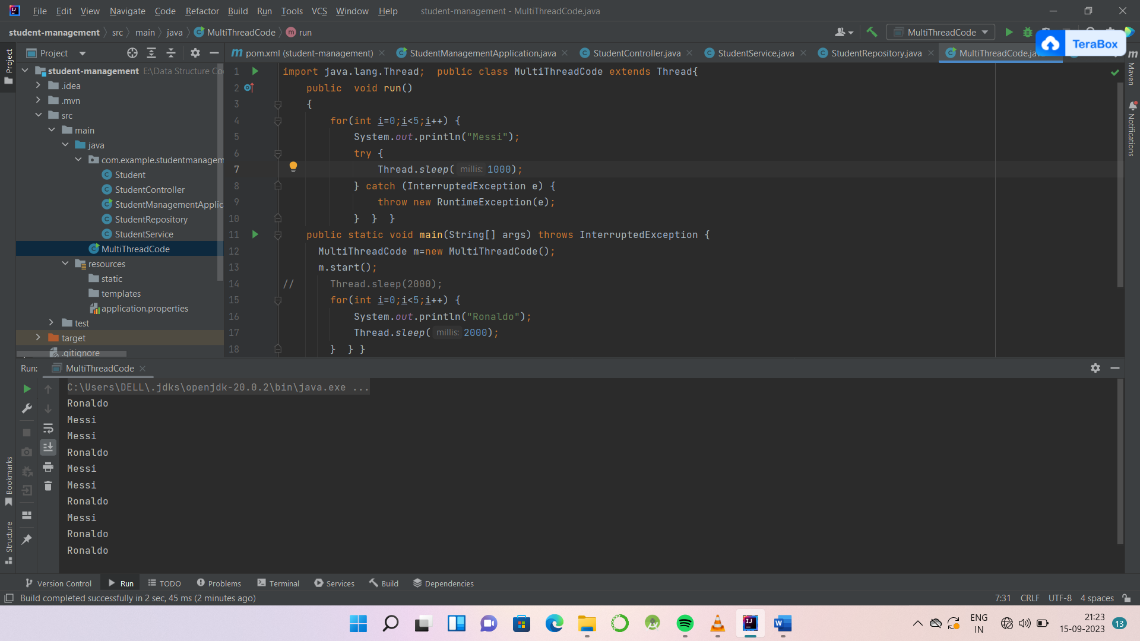

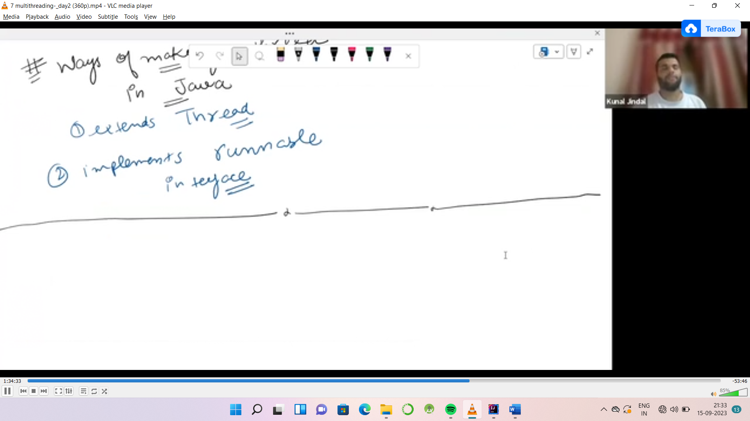

public class MultiThreadCode implements Runnable{  
 public void run()  
 {  
 for(int i=0;i<5;i++) {  
 System.*out*.println("Messi");  
 try {  
 Thread.*sleep*(1000);  
 } catch (InterruptedException e) {  
 throw new RuntimeException(e);  
 } } }

MultiThreadCode m=new MultiThreadCode();  
Thread t=new Thread(m);  
t.start();

**Race Condition:**

**DeadLock:**